C

Project Initialization and Planning Phase

Date | 15 July 2025
Team ID | xxxxxx
Project Name | A Comprehensive Measure of Well-Being
Maximum Marks | 3 Marks

Define Problem Statements (Customer Problem Statement Template):



Create a problem statement to understand your customer's point of view. The Customer Problem Statement template helps you focus on what matters to create experiences people will love. A well-articulated customer problem statement allows you and your team to find the ideal solution for your customers' challenges. Throughout the process, you’ll also be able to empathize with your customers, which helps you better understand how they perceive your product or service.

Example:
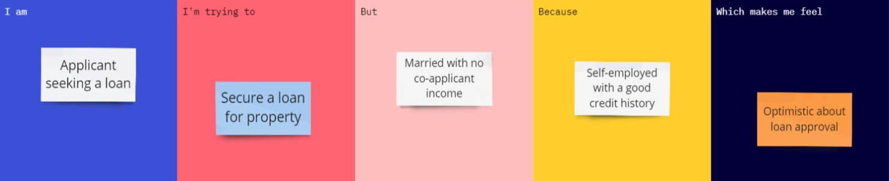

Problem  Statement  (PS) | I am (Customer) | I’m trying  to | But | Because | Which makes me feel
PS-1 | A researcher, policymaker, or student interested in evaluating a country's development. | Predict the Human Development Index (HDI) category using life expectancy, education, and GNI per capita. | I cannot accurately determine the country's HDI level manually. | There is no easy-to-use application that analyzes these indicators together and instantly predicts the HDI category. | More confident in understanding a country's development status and identifying areas for improvement.

